Configure VPC peering in cross regions.
Purchase one domain from GoDaddy.
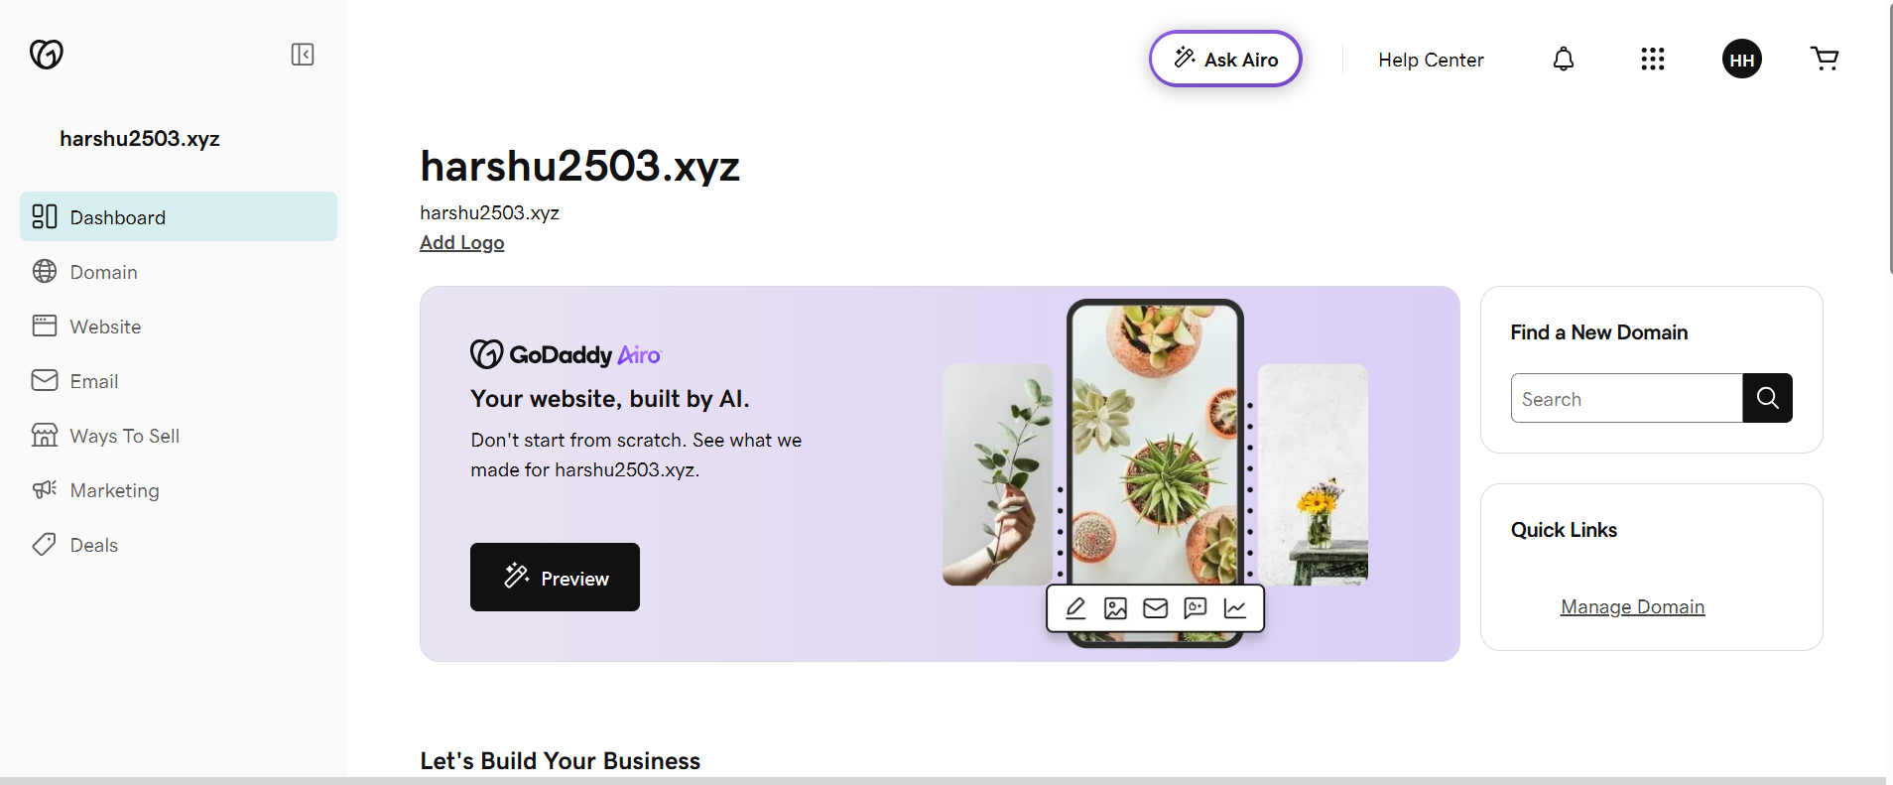
Deploy static website in S3.
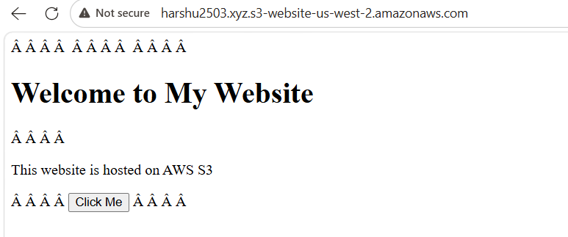
Create a CDN and attach one SSL certificate.
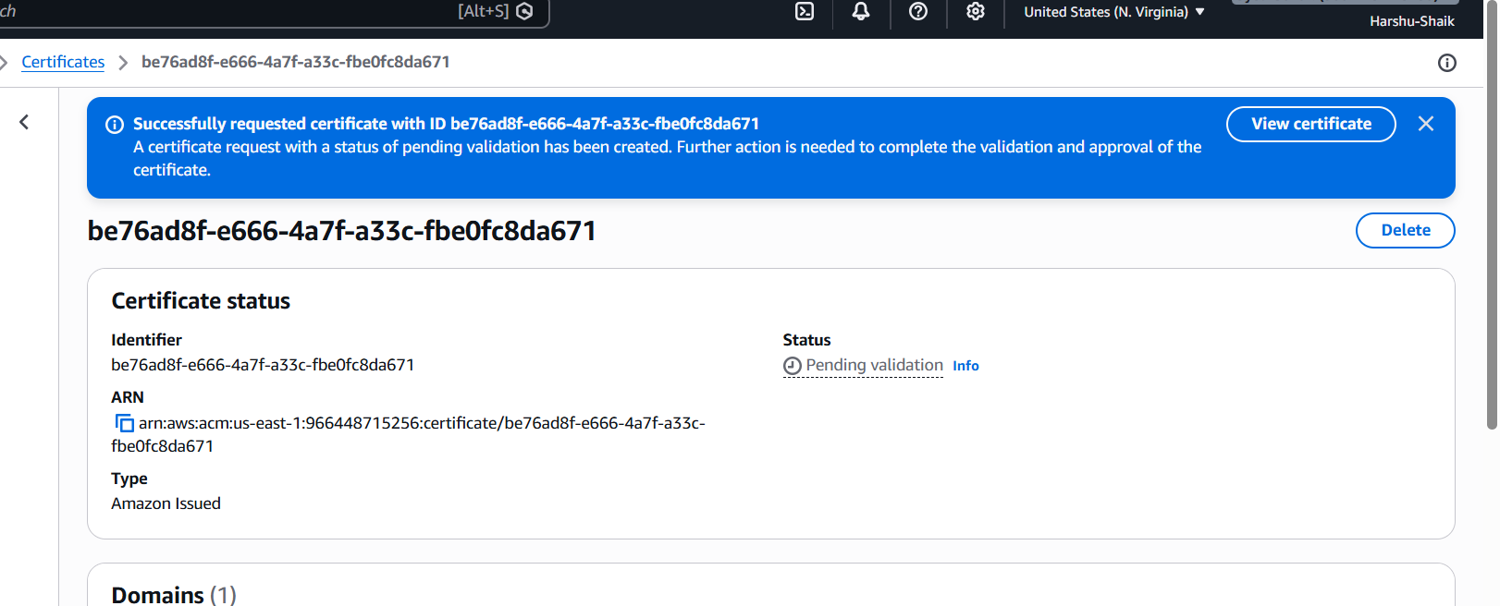
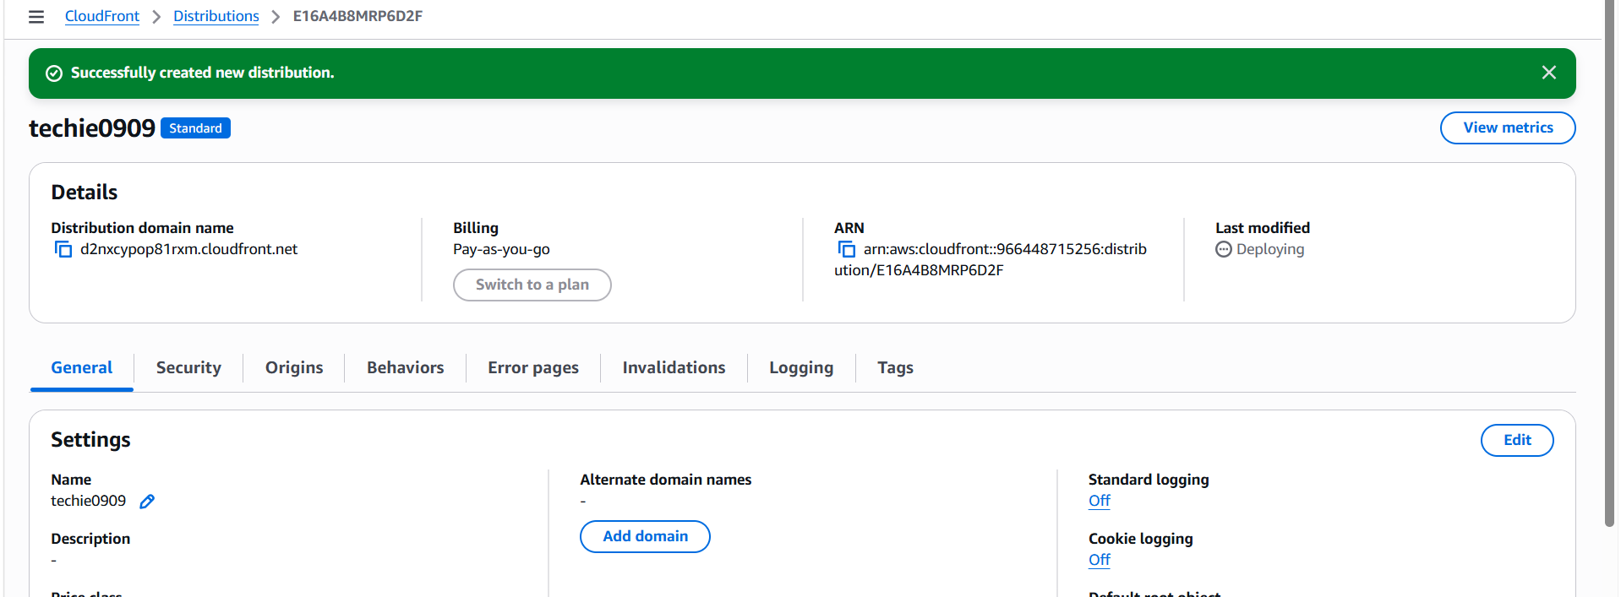
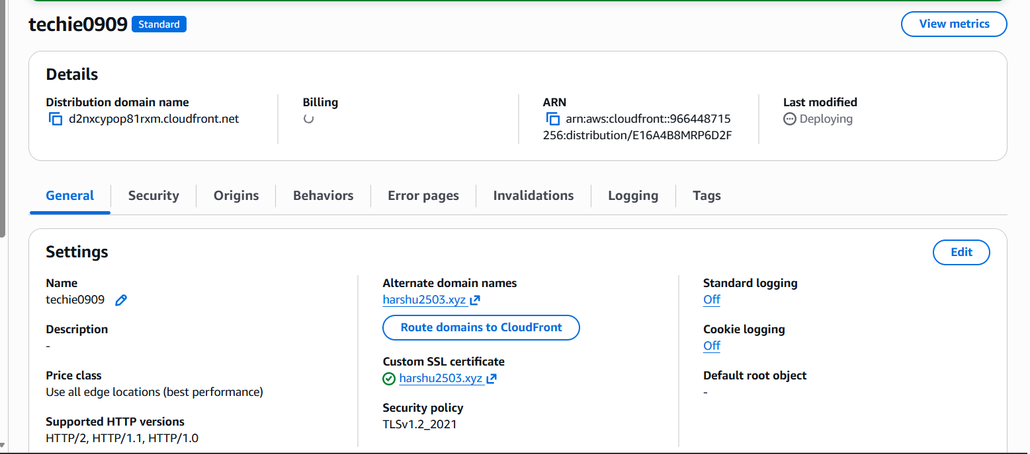
Create a Route 53 hosted zone and map the domain with the CDN.
Click to route 53
click to hosted zone and create hosted zone
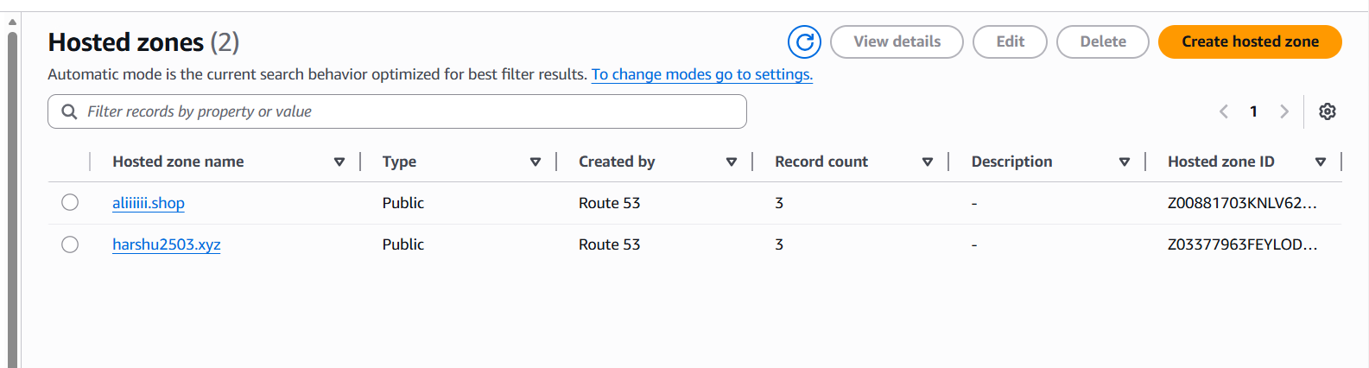
Create record by default we have naming servers
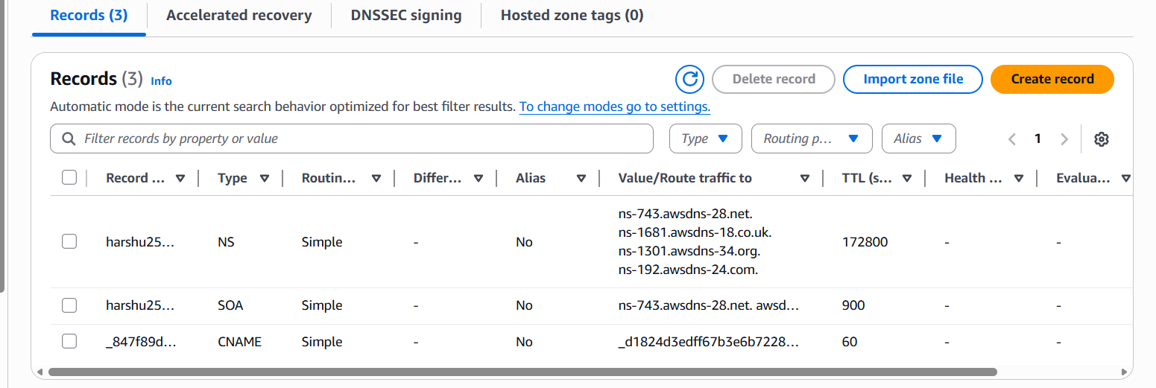
Copy the nameservers and to the godaddy in the nameservers
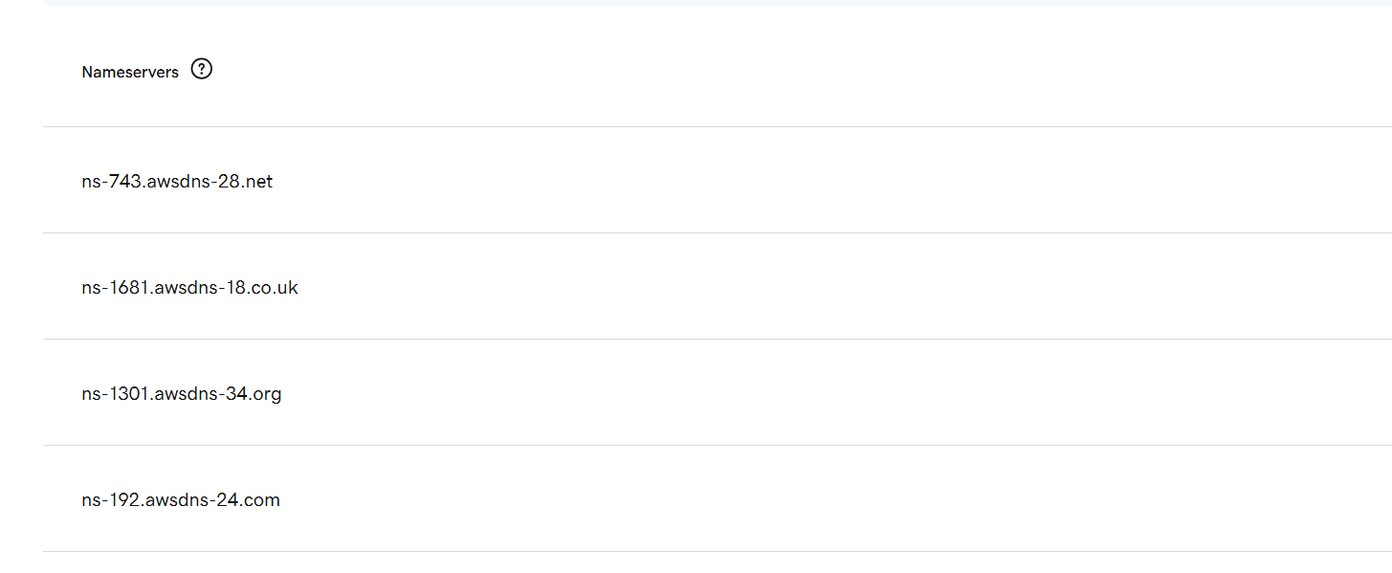
Update the index.html in the S3 bucket and ensure the updated file is
accessible using the domain name.
We can update anything in the index.html file

Upload to the my S3 bucket and go to S3 bucket enabling the versions
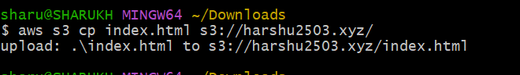
In cloud front we have invalidations create invalidation and giving path
like(*/) click to create
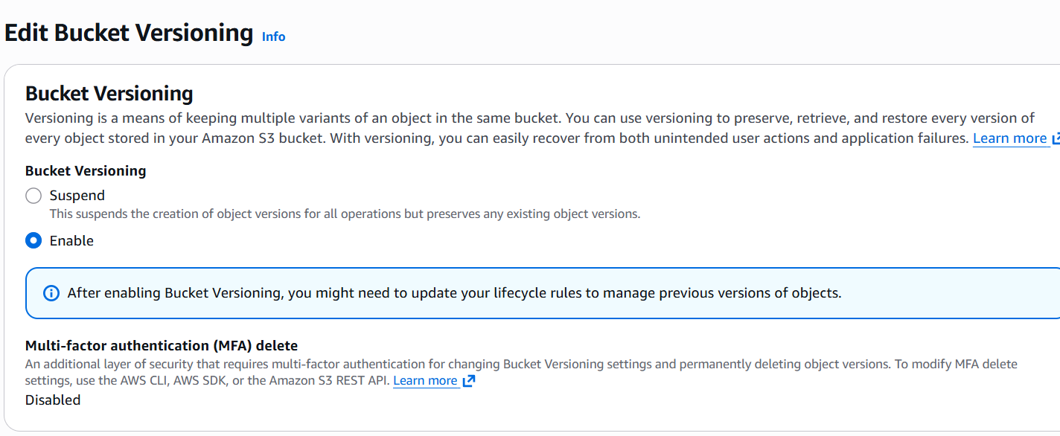
Now check with domin you can saw the changes
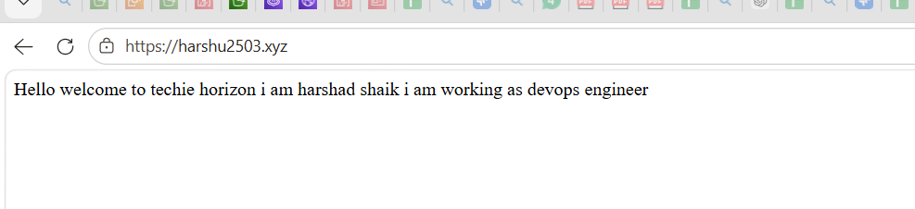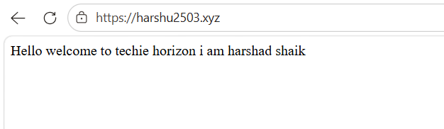

Share the domain name in Slack to test the connectivity.
Harshu2503.xyz

